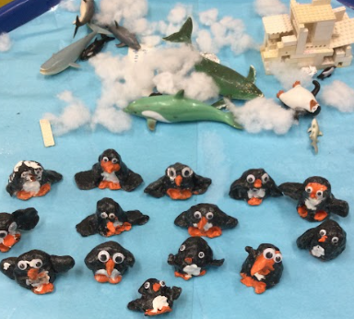
Spring 1
Little Explorers

Literacy & Phonics
Revise all set 1 sounds and begin set 2 sounds
Link sound to the letters to blend and segment.
Read and write some common irregular words e.g. the, was, to, he, she, me, we
Begin to write simple words and phrases
Listen attentively to stories linked to our topic

Mathematics
Counting and comparing groups to 10
Introducing zero
Composition of numbers to 8
Combining two groups
Making pairs
Compare mass and capacity
Length, height and time

Personal, Social & Emotional Development
Keeping Myself Safe
Exploring different ways of keeping ourselves safe in everyday life and online
Listening to my feelings.
People Who Keep Me Safe.
Physical Development
Static Balance
Seated Balance
Dance
Develop knife and fork skills
Develop ability to control tools and pencils for writing
Communication & Language
Express likes, dislikes and needs
to a familiar audience
Show back and forth conversations
Maintain attention and concentrate
Use correct pronouns when speaking

Expressive Arts & Design
Colour: examine ‘Winter Landscape with skaters and bird trap’ by Brueghel (1565)
Create Chinese New Year puppets
Cutting skills
Moving to music
Understanding the World (History, Geography and Science links)
Recognise seasonal changes in Winter
Explore ice and melting, floating and sinking
Recognise there are cold and hot places in the world
Locate the Polar Lands on a globe/world map
Recognise different animals and their habitats
Draw simple maps of journeys
Compare how we live to a different country
Religious Education
Salvation – Find out about the story of the Good Samaritan
Examine how we can help others.
We are now focusing on…

