Expressive Arts & Design
- Look closely at still art by artists Paul Cezanne and Francisco de Zurbarán)
- Draw and paint still life pictures of fruit and flowers
- Use mixing skills when creating art pieces
- Explore musical instruments
- Follow a beat
- Perform a song to an audience
Summer 1

How does your
Garden Grow?
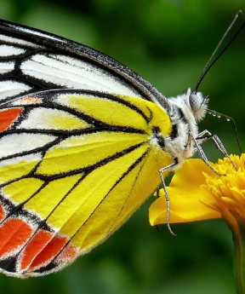
Personal, Social & Emotional Development
- How can we care for nature and the animals of the world?
- Know the growing stages, from baby to old age
- Naming body parts
- Know how to keep ourselves safe

Physical Development
- Develop coordinating
- Sending and receiving ball skills
- Hold a pencil with good control for writing
- Use tools such a scissors and knife and fork
Communication & Language
- Show attentive listening and respond to questions
- Explain why things happen
- Hold back and forth conversations
Religious Education - Special Places
- Explore which places are special to me and why?
- Where is a special place for Christians?
- Where is a special place for Muslims?
Understanding the World (History, Geography and Science links)
- Explore the Summer season – weather, growth of flowers, garden creatures
- Learn how to grow and care for a bean plant?
- Observe how a butterfly grows and changes, sequencing its lifecycle (egg - caterpillar – butterfly)
Mathematics
- Counting to 20 and beyond
- Ordering numbers to 20
- Addition with single digit numbers
- Subtraction with single digit numbers
- Doubling
- Sharing and grouping
- Spatial awareness

Literacy & Phonics
- Revise Set 2 sounds reading and writing words that feature them

ay ee igh ow oo oo ar or air ir ou oy wh kn

- Write simple sentences with gaps between words
- Show some awareness of a capital letter and a
full stop
- Attempt writing in different forms – letters, lists,
and stories

We will be learning to…

